

***LAB REPORT 2***

***Muhammad Rafay***

***20P-0018***

***Computer Networks***

***Sec A***

**TASK 1:**

**A.**

PC’s connected using Ethernet and then have verified the connection using ping command.

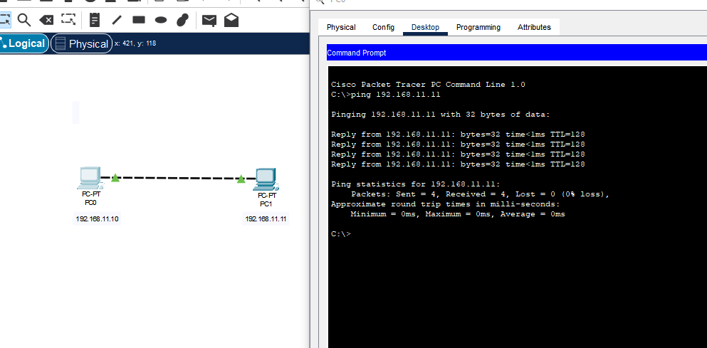

**B.**

Requested time out because the network is change .

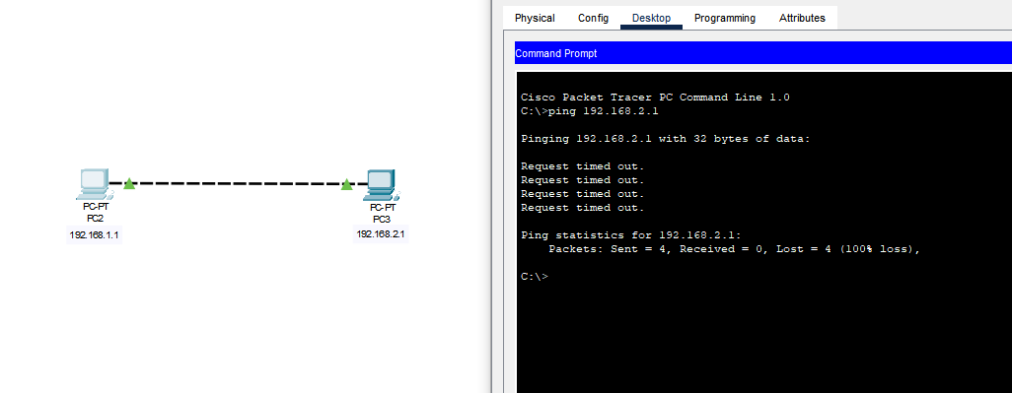

**C.**

Connection is successful because of same subnet mask

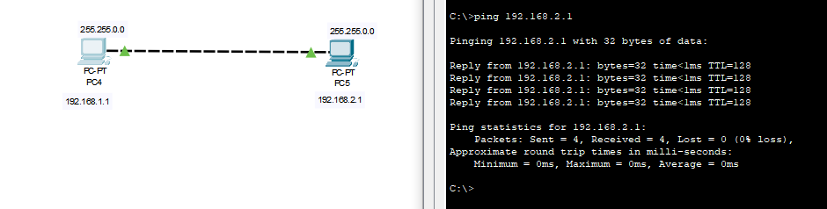

**TASk 2:**

Connecting Multiple devices(PCs) to Hub to create a connection

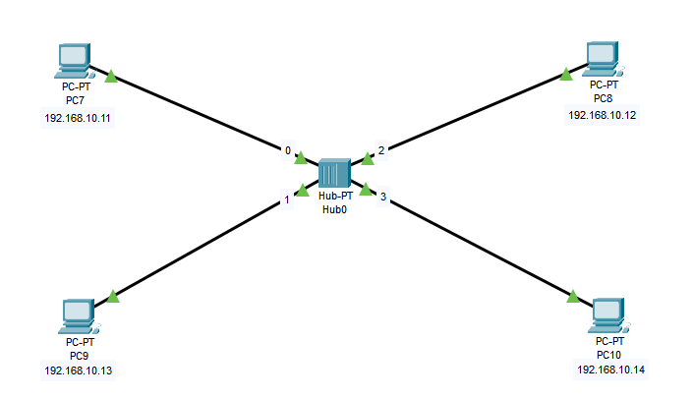

Verifying by sending a message from PC 7 to PC 9.

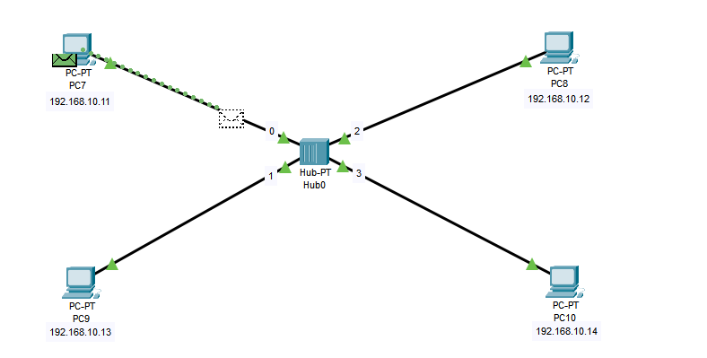

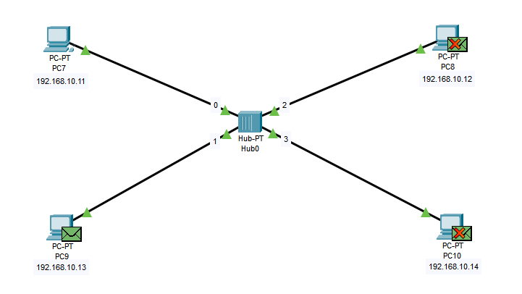

**TASK 3:**

To cover draw back we faced in HUB while verifying a connection between different networks we are using Switch.

Ping From Laptop 1 to PC-12

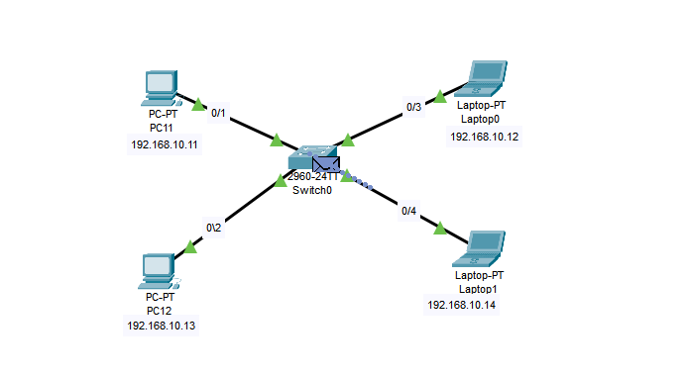

Reached to Switch From Lap-1

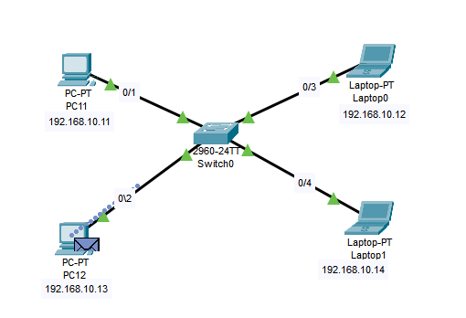

Transferred to PC12 from SWITCH

Now Pinging From PC12 to LAP-1

